**Purpose of the ontology/conceptual model:** What is the purpose of representing the reality as describe in the following.

**Entity type**: (Name of entity)

**Delimitation**: (Tangible/Classification/Definition)

**Describe method of delimitation**:

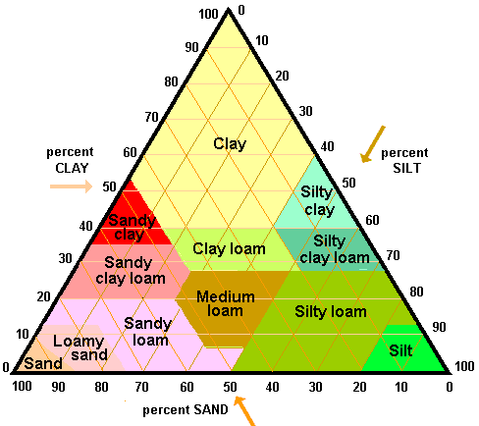**For a tangible**  delimitation describe in as precise terms as possible what identifies and delimitates the entity see <https://www.ordnancesurvey.co.uk/documents/os-mastermap-topography-layer-product-guide.pdf> page 11 for the uk definition of a building and <http://geodanmark.nu/Spec6/HTML5/DK/StartHer.htm#GEDS6-DK/3.1.1%20Bygning.htm%3FTocPath%3D3%25201%2520BYGNINGER%7C_____1> for the danish definition of a building( in Danish)

**For classification** insert a definition of the values used in the classification for instance in the form of a diagram as the soil diagram.

For entities based on definitions specify the source and time of the definition (if possible)

**For all methods** specify a desires precession, minimum mapping unit and any spatial constraints (e.g. allow overlapping or that all areas must be covered)

**Delimitation temporality:** (When the delimitation is preformed and if it is a moving entity how often the delimitation is updated and is the history saved.

For each property describe:

**Property name:** Name of the property e.g. building hight

**Property description:**  A description of what the property is and how it should be collected.

**Property domain:** What type of observation (text, number, date, image etc) if it is a classifier e.g. building type specify the different categories and there definition.

**Property temporality**: When the property is observed and if it changes over type how often is it updated (and is the history saved)

**Property Field**: name of the property e.g. elevation over sea level

**Property description:**  A description of what the property is and how it should be collected.

**Property temporality**: When the property is observed and if it changes over type how often is it updated (and is the history saved)

**Diagram components**

|  |  |
| --- | --- |
| Entity type | Building |
| Property |  |
| Dimensional Property |  |
| Property field | Elevation |